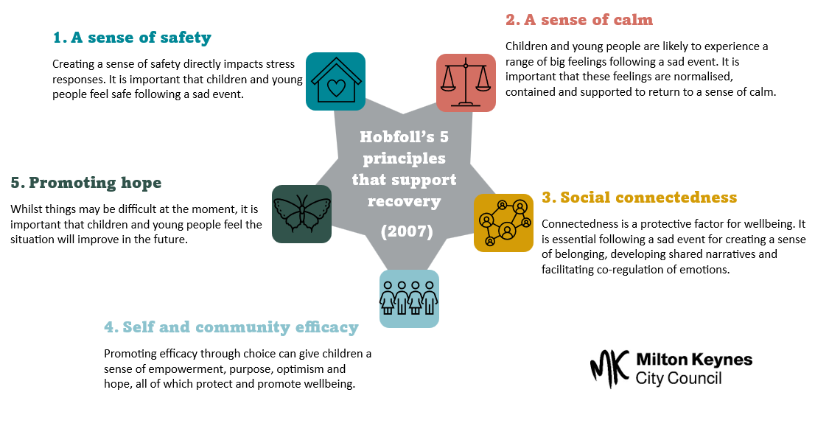

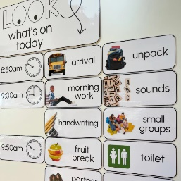

A sense of safety

**Safe conversations**

Adults should show that they are willing to talk about the event, and create opportunities for private discussions if needed, for example, through the child or young person staying behind to ‘help’ with a task.

Adults should:

* Answer questions accurately and honestly.
* Listen with full attention [see active listening].
* Avoid emphasis on advice or interpretation.
* Give the message that the feelings expressed are natural and normal.

Some children or young people may not want to talk, and this should be respected. They may prefer to use painting, drawing, or play.

When something is too upsetting to talk about, we don’t have to avoid it. We can stay with the upsetting thing by talking about and holding it safe in a different way. We can talk about the ‘thing’ without talking about the ‘thing’. For example:

* “If It was a colour, what would it be?”
* “If it was an animal, what would it be?”
* “Is it quiet or loud?”

Children can be encouraged to draw around their hand and label it with adults they feel safe to talk to. Here’s an example of what this could include:

**Creating structure and routine**

Creating structure and routine will increase predictability, which will increase feelings of safety.

The use of a class visual timetable will help to remind children and young people what is coming next and can be used as a reference point throughout the day. This could include pictures for younger children or be a list with timings for older children.

This can also help to emphasise what is staying the same, which can feel helpful when things are feeling different or out of control.

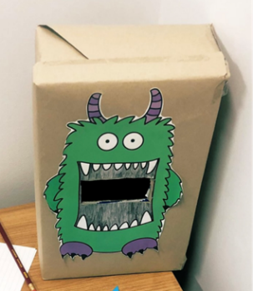

**Worry boxes and worry eaters**

Worry eaters are often plush toys with zipped mouths. However, you can get creative and create your own (e.g., using an old shoe box).

Worries can be written on paper and put inside the mouth. You can introduce these in a playful way e.g., ‘this is Mitch the monster, he loves to eat children’s worries so that they don’t need to worry anymore!’.

For some children and young people, writing down and disposing of their worries is enough. For others, it can be helpful to explain that you will talk to the worry monster and come up with some solution to help the child to deal with their worries, and then open up this conversation with the child.

For older young people, a class worry box could be a good idea. Anonymous worried could be addressed as a class and solutions found together (this could be done in a discrete way, such as identifying themes and holding general discussions during a class circle time.

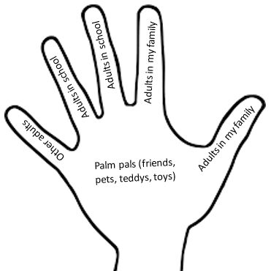

It is also important that as part of this, children and young people know how and when they can reach the identified trusted adults in school.



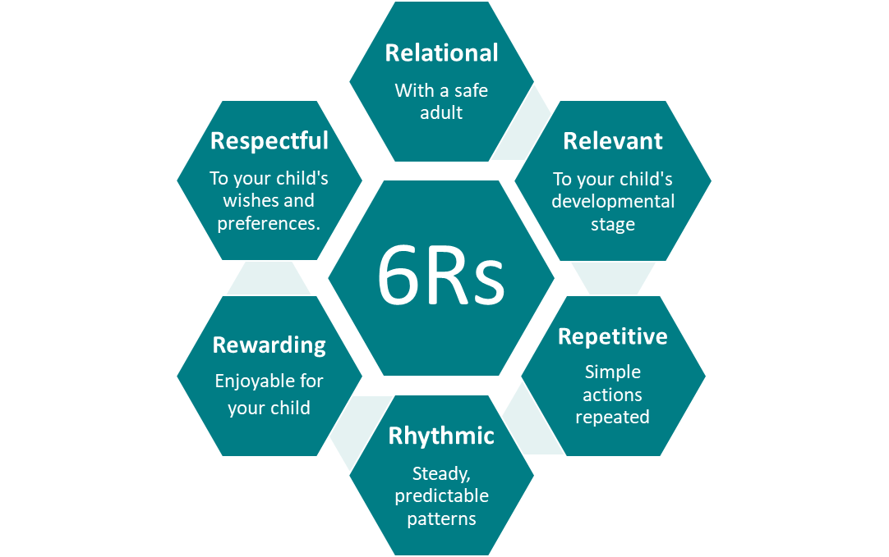

**Breathing exercises**

Breathing exercises are the foundation of many other relaxation techniques and are very easy to learn. They produce a bodily response that lowers stress and anxiety in the body.

Deep breathing techniques all have one thing in common, they work by stimulating what is known as the Parasympathetic Nervous System which is the opposite of the fight/flight/ freeze response (Sympathetic Nervous System).

Tracing shapes can be an engaging way to encourage children to take part in breathing exercises.

**Emotional regulation**

When children have experiences loss, they may struggle to manage the intensity and duration of their emotions, resulting in them becoming easily dysregulated. You can support a child to stay regulated by giving them opportunities to take part in regulating activities that can help them to cope with these emotions. The below visual is not an exhaustive list, but provides some examples:

A sense of calm

**Brainstem calming activities**

Activities that are patterned, repetitive and rhythmic can move children from a state of high anxiety to a state of calm. The ‘6R’ principles can be used to guide the activities that you plan and choose:

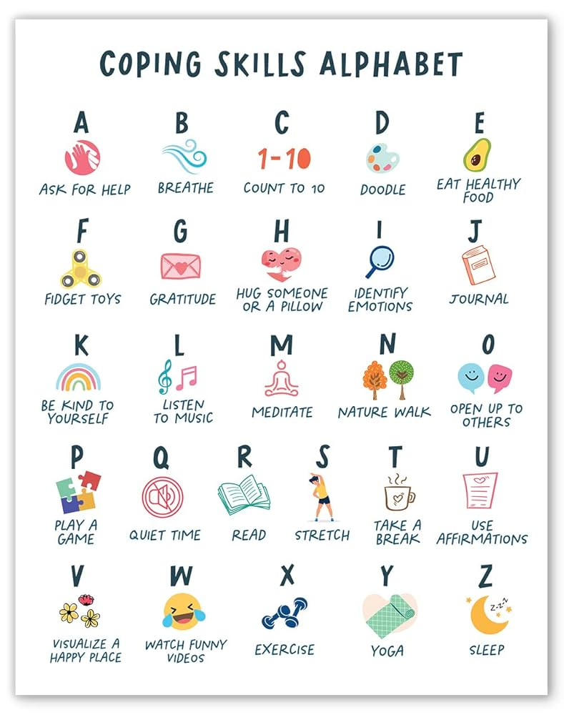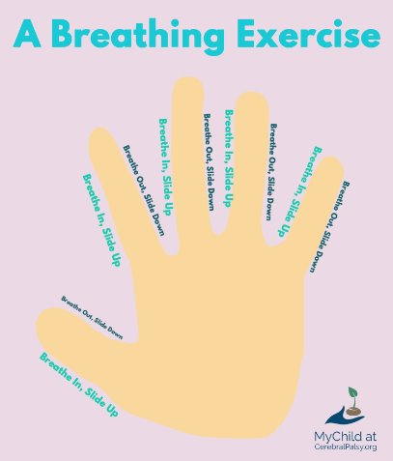

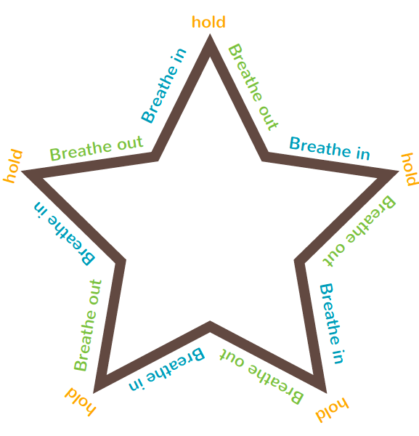

Examples of brainstem calming activities:

**Active:** walking, running, jumping, bouncing on a trampoline, bouncing a ball.

**Musical:** drumming, tapping or clapping a rhythm, singing, listening to music.

**Breathing:** counting in and out breaths.

**Movement:** swinging, rocking, swaying, yoga, tai chi.

**Counting:** counting forward, backward, in twos, with counters, number of real-life objects (e.g., birds in the sky).

**Resource:** [Brainstem Calmer Activities | Beacon House](https://beaconhouse.org.uk/wp-content/uploads/2019/09/Brainstem-Calmer-Activities.pdf)



Star breathing

****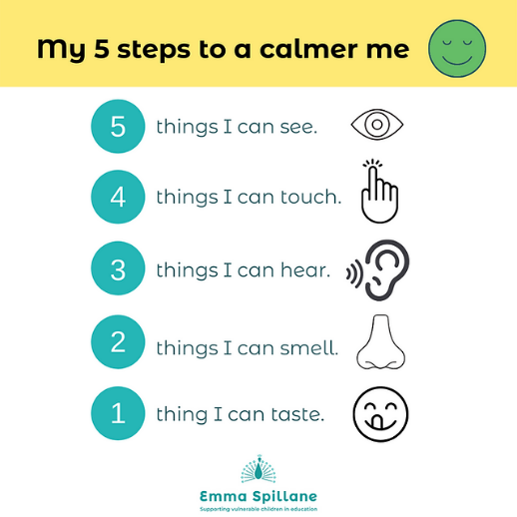

**Grounding exercises**

The 54321 technique is incredibly effective for bringing anxiety levels down. It does so by engaging the senses and anchoring us in the present moment.

Some tips for using this technique:

* Focus on as much detail as you can (e.g. I can see a big, dark blue chair with a high back).
* 'Notice' out loud (though this isn't essential, especially since you might use this in a group).
* If you can't really taste something, imagine eating your favourite food and how that would taste.
* Don't rush through it - inhale and exhale slowly as you focus on each of the senses.

**Guided relaxation**

Guided relaxation can help children to feel calm and relaxed. There are many possible scripts available online (see links below for examples) and you can also develop your own based on your child’s safe and happy place.

[Secret Garden Meditation Script for Kids | Green Child Magazine](https://www.greenchildmagazine.com/secret-garden-meditation/)

[Kids' Guided Meditation for Emotional Release | Green Child Magazine](https://www.greenchildmagazine.com/guided-relaxation-beautiful-dragonfly/)

Hand breathing

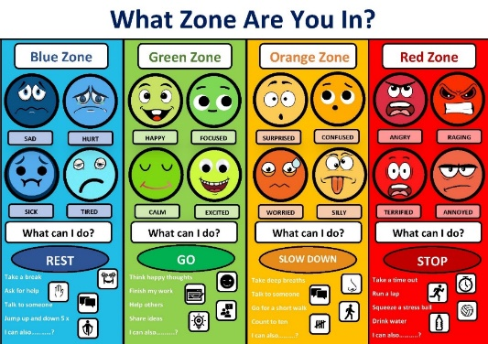

Social connectedness

**Restorative conversations**

Following a sad event, children may show a change in behaviour. Restorative conversations is an approach for dealing with conflicts and challenging behaviours that focus on resolution, repair and relationship over guilt, blame and punishment.

Key points for facilitating restorative conversations:

* Acknowledge unique perspectives.

*Start from the beginning, what happened?*

* Reflecting on thoughts and feelings.

*What were you thinking? How did you feel? How do you feel now?*

* Considering impact.

*“Who has been affected by this?”*

* Considering needs.

*“What do you need to move forward? What would make things better for you?”*

* Thinking ahead.

*“What are the next steps? What are we going to do moving forwards?”*

**Everyday relational approaches**

Having a sense of belonging is crucial for wellbeing. Adults can foster a sense of belonging by using everyday relational approaches. Evidence based relational strategies include:

* Emotional check-ins (use of visuals can be useful here)
* 5 pieces of praise to 1 piece of criticism ratio
* Recognising and acknowledging positives through praise
* Knowing at least one thing about each pupil (e.g., an interest).
* Non-learning related conversations
* Brief 1:1 time with trusted adults
* Sending positive messages home
* Greeting each child by name
* 2 minutes of non-problem talk, 10 times a day.

“The ‘everyday magic’ that this entails is surprisingly simple but can have far-reaching outcomes for student wellbeing. The things that students said mattered were teachers listening, helping when they got stuck with work, being positive and encouraging, being an advocate and sticking up for them, taking an interest in them as people such as remembering birthdays, being able to have fun and share a joke, empathise with their difficulties and simply ‘being there’ - accessible in times of need.” ​- Sue Roffey​

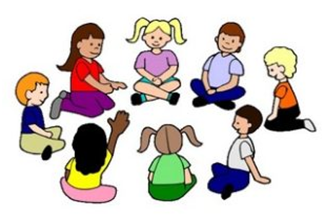

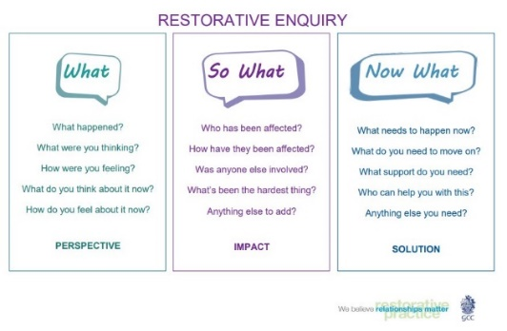

**Emotion coaching**

During times of turbulence, such as following a sad event, children may need help to regulate their emotions. This is referred to as co-regulation. Emotion coaching is a relational approach in which adults help children to become aware of their emotions whilst setting boundaries and helping them to problem solve.

1. Be aware: “I can see you are struggling to get ready for school today.”
2. Label: “I’m wondering if you are feeling worried about going on the trip today?”
3. Empathise and validate: “I know that change can be difficult as we don’t know what to expect. I would feel worried too.”
4. Set limits and problem solve: “If we avoid things that are different then we don’t get to try new things we might enjoy. Perhaps it would help if we found some pictures online so you can see what it looks like?”

**Circle times**

Circle times are an opportunity to get to know children and their interests. Conversations at circle times can be as simple as “what’s one thing that you enjoyed at the weekend?”. Circle times can also be used to explore whole class issues such as conflict at playtime and emotional regulation.

Circle time is also a practical way to skill children to listen with understanding and tune into their feelings. The goal of circle time is to build group cohesion and a sense of community and connectedness through familiarity, respect, friendship, and open conversations.

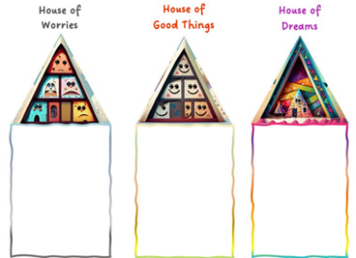

Three Houses​

*An activity to explore things that are going well, worries and hopes and dreams for the future.*

The Ideal School​

*Young people are asked to draw their ‘best’ or 'ideal' school and to consider how close their current setting is to this imaginary place*

Comic Strip Conversations​

*Sharing thoughts, feelings and views through creating comic strips.*

Conversation cubes and sentence starters

*Activities to ‘start the conversation’ and prompt important discussions.*

Stress Bucket (YoungMinds)​

*The stress bucket worksheet helps young people identify what is causing them stress (the taps above the bucket) and develop strategies to reduce this (the taps below the bucket).*

**Doing ‘with’ rather than ‘to’**

Efficacy is about believing that you have the skills and ability to cope and manage. Following a sad event, children may lose this feeling. Schools can promote efficacy by providing agency through allowing them opportunities to exercise choice and control in essence doing things ‘with’ them, rather than ‘to’ them. Efficacy can give children a sense of empowerment, purpose, optimism and hope, all of which protect and promote wellbeing.

Self and community efficacy

**Gathering children’s views**

Gathering the views of children can assist in encouraging and ensuring their voices are being listened to and they are having choice in decisions being made. There are many ways of gathering children’s views, below are some examples of activities to support children in sharing their views.

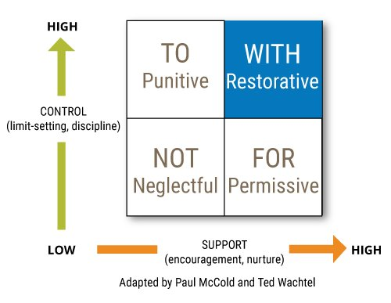

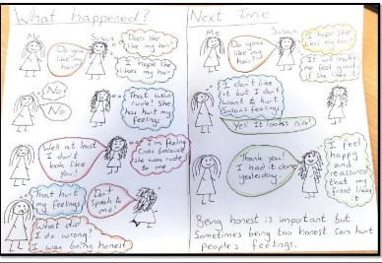

**Acts of kindness**

Acts of kindness promotes the notion that whilst we cannot control what has happened, we can control how we react. Research shows that random acts of kindness and helping others can reduce stress and anxiety and improve our emotional wellbeing. Action for Happiness have lots of ideas on acts of kindness. These acts do not need to be big gestures, some ideas are:

* Thank someone for something they have done (in person, or through a letter or card).
* Draw a picture or make a card for someone.
* Give someone a compliment.
* Smile at 5 people that you walk past.
* Read a book to a friend or sibling.

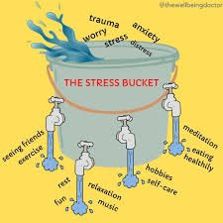

**Motivating roles and responsibility**

 Giving children motivating roles or responsibilities that they are happy to do gives them a sense of belonging and efficacy. You could also discuss how the roles that children are taking on is contributing to the collective wellbeing or running of the classroom.



Promoting hope

**Building resilience**

Resilience is the belief that we can overcome difficulties and ‘bounce back’ from challenging times. Resilience is not something we have or are born with, but it is something that is built over time. Building individual and whole-school resilience can help children to cope with and move forwards following a sad event. It will also foster hope that although things are tough now, we have the skills and capability to move forwards in a strength-based way. Below are some examples of activities and strategies for building resilience:

Celebrating achievements

* *Design praise boards.*
* *Create “sparkle moments” diaries or scrapbooks e.g., ‘book of achievements’.*
* *Celebrating achievements in assemblies.*
* *Certificates to present in assemblies.*
* *Journey or jewel jars.*
* *Tower of strengths (this can be made fun through building Lego towers)*
* *Patchwork of positives.*

Play

*Play is a powerful tool for fostering and promoting children’s resilience. Through play, children build many skills needed for resilience, including developing solutions and problem-solving, thinking creatively, developing emotional regulation, building confidence. Play also allows children to experience positive feelings as well as express and process strong feelings such as fear, loss and anxiety following a sad event. Play opportunities may include:*

* *Small world toys such as dolls houses.*
* *Arts and crafts.*
* *Sand/water play.*
* *Imaginative role play.*
* *Musical instruments.*
* *Building models (Lego, recycled materials).*
* *Board games with a peer/adult.*

**Hope clouds**

Instilling a sense of hope can be one element of helping children to build resilience. Discuss with the class what it means to be ‘hopeful’ and how hope might be able to help us to cope in challenging times. Encourage children to think about their own dreams and hopes and write them down on a hope cloud. Children may wish to share their dream or hope with the class. Children can be encouraged to take their clouds home, or they could be displayed all together to create a sky of hope, as a visual reminder of being hopeful.

[Young Minds – Hope Clouds](https://www.youngminds.org.uk/media/qtlpw144/hope-clouds.pdf)



**Three good things**

‘Three good things’ is a solution-focused activity that can bring us back to focusing on the positives and practicing gratitude during challenging times. Three good things can be used flexibly, for example children can write three things, draw them, share them during a circle time, make them into a song or poem, display them on 3 gold stars. It could be three good things about the day, three good things about a lesson, three good things about school in general, three good things about their skill set.

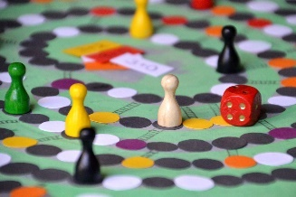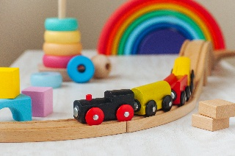

**Positive self-talk and affirmations**

Positive self-talk and affirmations can significantly impact children’s mindset. Practicing this thinking can reduce stress, improve self-esteem and resilience, increase motivation and improve overall wellbeing. Adults can help children to develop and practice a number of phrases that might help them to think positively. Some examples below might get you started but you should also encourage children to come up with heir own ideas and phrases so that the words have meaning for them.

*“This is tough, but so am I”.*

*“I may not be able to control this situation, but I am in charge of how I respond”.*

*“I am brave”.*

*“I am grateful”.*

*“I can do anything I set my mind to”.*



Further support

**A note on self-care**

Experiencing loss or a sad event within the school community can have wide reaching impacts. Working with children, young people and families who have experiences trauma such as loss and bereavement brings additional complexities that may leave staff feeling overwhelmed. It is important to take time to reflect on our own wellbeing so that we can recognise when you are feeling overwhelmed or stressed and react appropriately.

Staff should be encouraged to create personal wellbeing plans to prevent burnout and stress and replenish themselves during challenging times. The NHS promote 5 ways to wellbeing, which are 5 evidenced based principles to improve mental health and wellbeing, promotes positive feelings and enables us to get the most out of life.

**Support within Milton Keynes**

* You can find a list of guidance for schools and settings, as well as other helpful resources, on the Educational Psychology Team section on Milton Keynes SEND Local Offer under ‘Critical Incidents’:

<https://www.mksendlocaloffer.co.uk/education-and-send/what-send-team-does/educational-psychology-service>

* Harry’s Rainbow is a Milton Keynes charity offering support for bereaved children:

[Homepage - Harry's Rainbow](https://harrysrainbow.co.uk/)

* Mind BLMK offers support around mental health and wellbeing, including drop-ins and peer support, as well as support around bereavement by suicide.

[Milton Keynes - Mind BLMK](https://www.mind-blmk.org.uk/how-we-can-help/milton-keynes/)

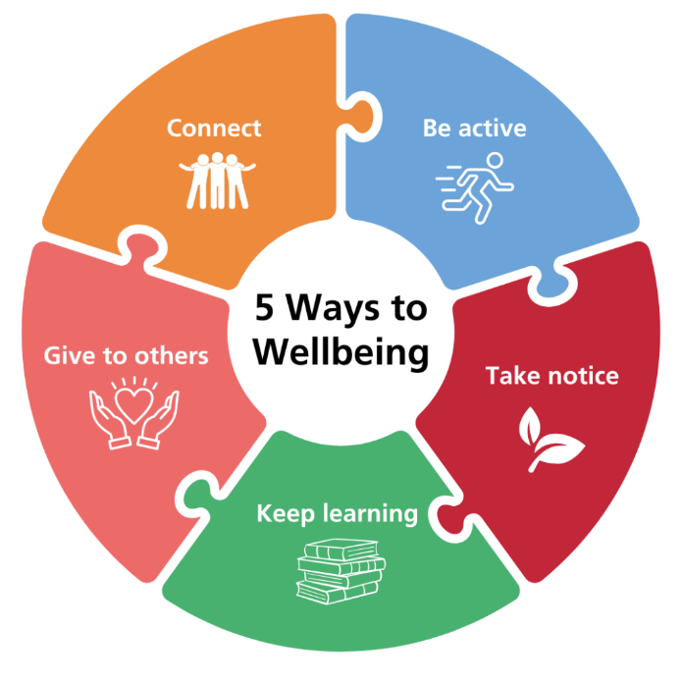

**Other helpful resources**

* Cruse Bereavement Care offer support to people after the death of someone close.

<https://www.cruse.org.uk/>

* The Compassionate Friends offer support for parents, siblings and professionals following the death of a child.

[The Compassionate Friends](https://www.tcf.org.uk/)

* Bereavement Advice Centre offers support, practical advice and resources following bereavement.

[Bereavement Advice Centre | Free Helpline](https://www.bereavementadvice.org/)

* Grief Encounter offer support for bereaved children and young people.

<https://www.griefencounter.org.uk/>



[5 steps to mental wellbeing - NHS](https://www.nhs.uk/mental-health/self-help/guides-tools-and-activities/five-steps-to-mental-wellbeing/)

**Illustration source**: [BLOG: Psychological Wellbeing Practitioner, Sam, provides advice on how to prevent low mood and anxiety - NHS Shropshire, Telford and Wrekin](https://www.shropshiretelfordandwrekin.nhs.uk/mental-health-support-psychological-wellbeing-practitioner/)