**Messy Play**

**Sensory Activities to support childrens Speech, Language, Communication and Interaction skills**

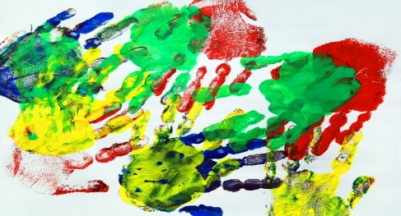

Our five senses are critical to our lives, helping guide us through everything from the daily tasks of walking, talking and eating to the more complex functions like creative and artistic projects, playing sports and critical thinking.

By stimulating the senses through what’s called Sensory play or Messy play, we can help develop our children’s creativity while also encouraging social, emotional, cognitive, physical, and attention development. Sensory play also helps strengthen the brain’s neural pathways and connections.

Some children, however, often have difficulty with everyday sensory stimulation, and this inability to cope with the world around them can make day-to-day experiences feel overwhelming and make it difficult for them to learn and carry out basic daily functions.

Fortunately, there are many sensory activities for children that can help change the way the brain reacts to touch, sound, sight, and movement. Engaging in sensory play is a fun way for kids to stimulate their brains so they can become better learners, benefit from a longer attention span, and learn how to communicate with their peers.

opied

Copied

Loading adLive

**What are the benefits of sensory/messy activities for children?**

When a child is fully engaged with all of their senses in a particular activity, more neural pathways are actually created in the brain! Sensory activities can benefit all children

Sensory play offers a natural (and fun) way for kids to discover, examine, and understand their world, which in turn helps develop their:

* **Language skills.** Engaging in pretend play helps develop a child’s language skills by increasing their vocabulary as they discuss their experiences.
* **Fine motor skills.** Manipulating small objects not only aids in hand-eye coordination, but it also helps strengthen the muscles in a child’s hands and wrists, which in turn helps develop their fine motor skills.
* **Gross motor skills.** Encouraging kids to practice their running, jumping, and throwing skills through pretend sensory play is an excellent way to develop their gross motor skills by strengthening their large muscles through fun body movements.
* **Social skills.** Engaging in pretend play with peers doesn’t just build little imaginations. It also teaches important skills like sharing and taking turns!
* **Self-control.** Sensory play helps develop a child’s ability to respond appropriately to sensory stimulation, which helps enhance their self-control and self-regulation.

**Examples of messy play activities that you could do at home:**

**(If your child likes to put items in their mouths then just be aware of the types of messy play that you are providing)**

* Rice play – rice in a big container with spoons, cups, sieves etc. Using language alongside such as pour, tip, stop, fill
* Water play – using the same resources as above and also including bubbles, food colouring, glitter……the list is endless!!! Many children love water play so be prepared with a change of clothes!!
* Shaving foam – great for making marks whilst using descriptive language – soft, pour,smell etc.
* Custard powder and water – this is a great activity for children that like sensory activities. The custard sets on their hands and then just add water to make it all gooey again!!
* Pasta, spaghetti, jelly, beans – have fun with food!! Food play provides a fun, sensory experience to children and if they don’t like touching the food then it can always go into a ziplock bag 😊

The most important thing with messy play is to enjoy these activities alongside your child.

The most important tool they have to support them in their communication development is you.