Making your own Mess Free Sensory Bags

**Warning**

**As with any play activity please do not leave your child alone with these bags, some of them contain small objects which may cause harm to your child if a child removes them. Always use good quality Zip-lock bags, ensure you double tape the top and replace any damaged or worn bags from your play.**

To make one sensory bag, you will need

* 1 cup of flour
* 6 tbls of water and food colouring
* **Good quality** zip-loc bags
* Sticky tape
* Small mixing bowl

[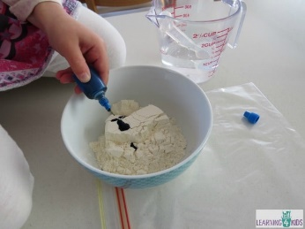](https://www.learning4kids.net/wp-content/uploads/2015/06/Add-food-colouring.jpg)**Step 1:**

* Place flour into a small bowl.
* Add food colouring.

**Step 2:**

[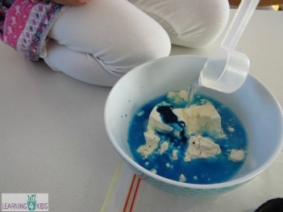](https://www.learning4kids.net/wp-content/uploads/2015/06/Add-water.jpg)

* Now add the water.

**Step 3:**   
  
+~/[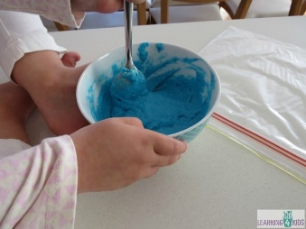](https://www.learning4kids.net/wp-content/uploads/2015/06/Blend-all-ingredients.jpg)

* Mix until all the ingredients are well blended.

**Step 4:**

[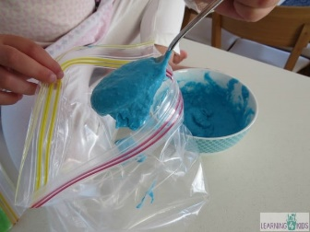](https://www.learning4kids.net/wp-content/uploads/2015/06/add-flour-mixture-to-freezer-bag.jpg)

* Scoop the flour mixture into the plastic zip-lock bag.

**Step 5:**

[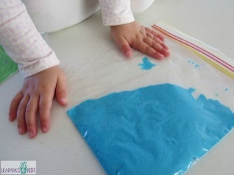](https://www.learning4kids.net/wp-content/uploads/2015/06/remove-all-air-bubbles.jpg)

* Before fastening the end, place the bag onto a flat surface
* Gently push any excess air out to avoid air bubbles.

[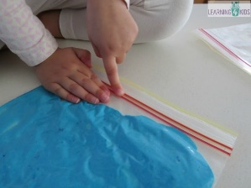](https://www.learning4kids.net/wp-content/uploads/2015/06/Fasten-the-opening.jpg)**Step 6:**

* Press the clips of the bag closed and ensure there are no holes.

**Step 7:**

[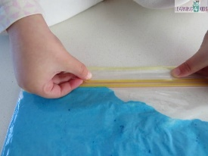](https://www.learning4kids.net/wp-content/uploads/2015/06/fasten-with-sticky-tape.jpg)

* Place sticky tape along the opening to secure the opening.

**Play Ideas**

* Use your finger, soft paint brush or a cotton wool bud to write your name, letters, numbers and shapes.
* Explore the squishy bag for a sensory experience, watch what happens as you squeeze, squish, press, etc.

Others ideas to fill your bag

* Hair Gel/hand gel
* Warm cooked oatmeal
* Paint
* Shaving cream
* Rice (try colouring your rice with food colouring/bury hidden treasure)
* Baby oil (try putting equal oil and water into the bag/food colouring)
* Play dough
* Letters/numbers
* Pom poms
* Small plastic toys
* Confetti
* Feathers
* Beads
* Water beads
* Leaves
* Shells
* Pebbles
* Flowers
* Stickers
* Glitter
* Marbles
* Buttons
* Popcorn kernels
* Pasta (cooked and uncooked)