**Sensory Team**

**Parents/carers and their children who are Deaf / Hard of Hearing group for 2024 - 2025**

**Thursday, 17th October 2024 from 10:30am to 12:00pm**

**at Rowans Family Centre**

**13a Moorfoot, Fullers Slade, Milton Keynes MK11 2BD**

[](https://www.google.co.uk/url?sa=i&rct=j&q=&esrc=s&source=images&cd=&cad=rja&uact=8&ved=2ahUKEwit39qj7v7gAhVRBGMBHV-UAekQjRx6BAgBEAU&url=https://www.localgov.co.uk/Council-support-for-deaf-children-in-disarray/44474&psig=AOvVaw1Z4Hf_EgvM3OkJ5Hh9rl5O&ust=1552557624823648)[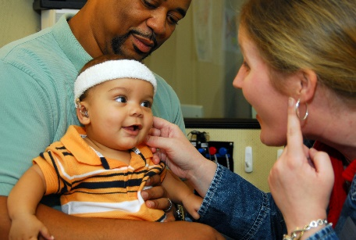](https://www.google.co.uk/url?sa=i&rct=j&q=&esrc=s&source=images&cd=&cad=rja&uact=8&ved=2ahUKEwjTq7u77v7gAhVQXBoKHdmnDUEQjRx6BAgBEAU&url=https://oberkotterfoundation.org/grants-2/&psig=AOvVaw2zUb1v589wyBAPbWliOWN7&ust=1552557742651717)[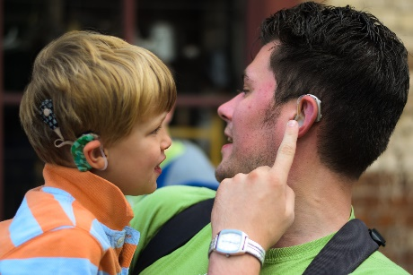](http://www.google.co.uk/url?sa=i&rct=j&q=&esrc=s&source=images&cd=&cad=rja&uact=8&ved=2ahUKEwjTq7u77v7gAhVQXBoKHdmnDUEQjRx6BAgBEAU&url=http://deafeducation.org.uk/free-information-days-2018-for-families-of-deaf-children-and-professionals/&psig=AOvVaw2zUb1v589wyBAPbWliOWN7&ust=1552557742651717)

**Come and join our sessions to…**

Meet other parents/carers and their children who are hard of hearing /deaf

Learn strategies to support your child

Learn more about communication with your child

Get advice and support from a range of professionals

And have fun!

**To let us know you can attend or if you have any questions, please email** [**Uday.thakrar@st-pauls.org.uk**](mailto:Uday.thakrar@st-pauls.org.uk) **or telephone 01908 669735 ext 147**

**Future sessions for 2024 – 2025:**

Friday, 15th November 2024 at 10:30am

Thursday, 12th December 2024 at 10:30am

Friday, 17th January 2025 at 10:30am

Thursday, 6th th February 2025 at 10:30am

Friday, 7th March 2025 at 10:30am

Thursday, 27th March 2025 at 10:30am

Friday, 9th May 2025 at 10:30am

Thursday, 12th June 2025 at 10:30am

Friday, 04th July 2025 at 10:30am

**Looking forward to seeing YOU and YOUR CHILD there!**