

Autism In Teens

Parent Programme

Five of the sessions will be on Microsoft Teams and two will be in person (venue TBC), you do not have to attend all sessions – once the invites have been sent out, just choose which sessions you would like to attend. For further information please see the link on <https://www.mksendlocaloffer.co.uk/programmes-and-workshops/parent-and-carer-programmes>

**To book your place please email us on**

[**SENDsupport@milton-keynes.gov.uk**](mailto:SENDsupport@milton-keynes.gov.uk) **stating**

**that you would like to attend the Autism In Teens parent programme.**

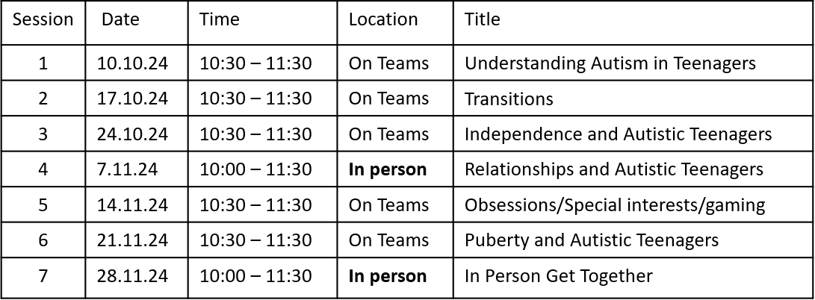

Five of the sessions will be on Microsoft Teams and two will be in person at **The Rowans Family Centre, 13a Moorfoot, Fullers Slade, Milton Keynes, MK11 2BD**. You do not have to attend all sessions – once the invites have been sent out, just choose which sessions you would like to attend.

**To book your place please email us on** [**SENDsupport@milton-keynes.gov.uk**](mailto:SENDsupport@milton-keynes.gov.uk) **stating** ​**that you would like to attend the Autism In Teens parent programme.**

**Summary of the sessions**

**Session 1 - Understanding Autism in Teenagers**

* Understanding how Autism may look in teenagers – a difference not a deficit.
* The positives of Autism and using these to support your child.
* How Autism may present itself differently in girls.

**Session 2 - Transitions and Autistic Teenagers**

* Preparing for change.
* Preparing for a new school/college.
* Supporting your teen when they start a new school/college.

**Session 3 - Independence and Autistic Teenagers**

* School/work.
* Life skills.
* Self-care.

**Session 4 - IN PERSON SESSION - Relationships and Autistic Teenagers**

* Family and friends.
* Understanding social rules.
* Keeping safe.

***This session will take place at The Rowans Children Centre, 13a Moorfoot, Fullers Slade, Milton Keynes, MK11 2BD***

**Session 5 - Obsessions, special interests, gaming and Autistic teenagers**

* Why do autistic teens often have special interests/obsessions?
* Positives of obsessions, special interests and gaming.
* Support with the negatives of gaming.

**Session 6 – Puberty and Autistic Teenagers**

* Puberty.
* Key skills to develop during puberty.
* Sexuality/gender.

**Session 7 – In person session –** An opportunity to meet other parents of teens with Autism and ask a specialist teacher questions.

***This session will take place at The Rowans Children Centre, 13a Moorfoot, Fullers Slade, Milton Keynes, MK11 2BD***

