|  |
| --- |
| Value Icons_FINAL_COL_0713 |

[](https://www.cnwl.nhs.uk/)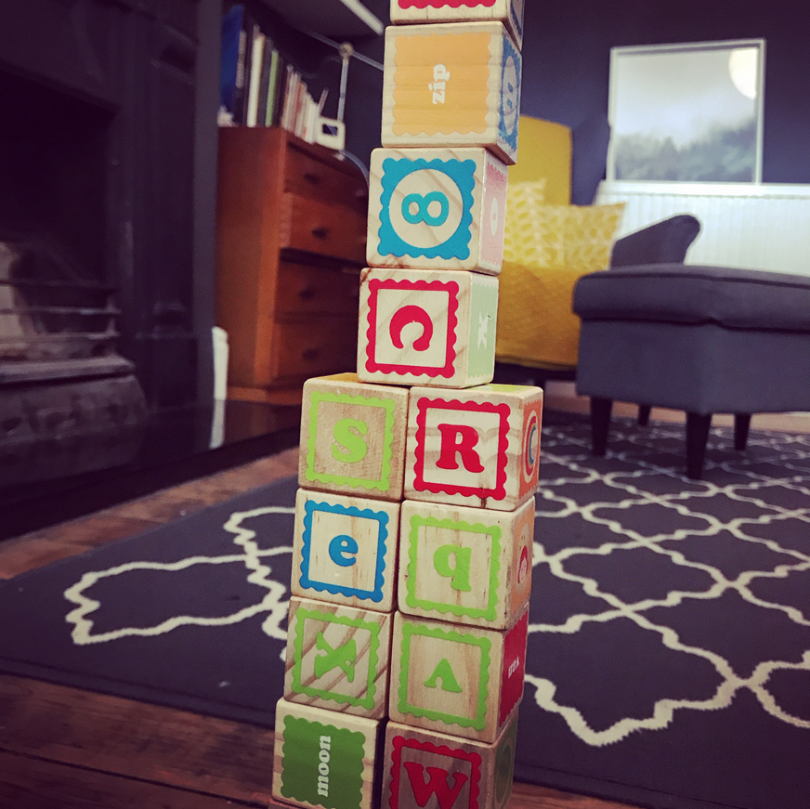

**Autistic Spectrum Disorder**

A guide to local and national resources

**Contents**

Introduction page 2

Support Groups and Organisations page 3

Parent Training Courses page 4

Financial and Family Support page 5

Education, Health and Social Care page 5

Databases page 6

Additional Useful Resources and Websites page 7

Reading list page 8

**Introduction**

**What is Autism?**

Autism is used to describe a spectrum of lifelong developmental difficulties that affects how a person communicates and interacts with people and their environment. All people with autism will have difficulties with communication, interaction and certain behaviours; however this will affect individuals differently. Some people with autism will also have difficulties with learning, mental health (such as aggressive behaviour or anxiety) or other conditions.

Therefore a diagnosis of autism is the beginning of a journey, and it is important to understand how autism affects each individual and what their needs are.

**Why am I receiving this booklet?**

You are receiving this booklet as part of an Autism information pack. This is because you or your child has been given a diagnosis of autistic spectrum disorder.

**How do I use this booklet?**

As described above, individuals with autism will have different strengths and weakness and it is therefore important to be aware of all the different resources and support available to children and their families. This booklet summarises some of the important resources both locally and nationally that can provide information and support in managing autism.

This booklet lists the resources that can be found in the autism pack which will allow you to focus on what you think you will need going forward. We would highly recommend that you attend one of the parenting courses listed on page 4. These provide information and training (usually over an 8 week period) to help parents understand their child’s difficulties and needs. They also provide sessions on managing behaviour and anxiety, which are common difficulties.

**What is the Milton Keynes Local Offer?**

The Milton Keynes local offer is the place to find local services for children and young people with special educational needs and disabilities. It is created for children and young people, their families and the professionals that work with them.

**Email:** [local.offer.feedback@milton-keynes.gov.uk](mailto:local.offer.feedback@milton-keynes.gov.uk)

**Web:** <https://www.mksendlocaloffer.co.uk/> & [www.facebook.com/mksend](http://www.facebook.com/mksend)

**Support Groups and Organisations**

|  |  |  |
| --- | --- | --- |
| **Resource** | **Description** | **Contact** |
| **The National Autistic Society** | This is the UK national society that provides training and information on a range of topics related to autism. Their website has a wealth of information and is an important resource for parents, carers and children. You will find information on autism, behaviour, anxiety, health and education. | <http://www.autism.org.uk/>  Education Rights: 0808 800 4102  Autism Helpline: 0808 800 4104  Parent-to-Parent Support: 0808 800 4106 |
| **NAS Milton Keynes coffee afternoons** | A support Group open to anyone with children, friends or relative with/without a diagnosis of autism. The group is a chance to access help and information. Meetings on first Thursday of the month 13:00-14:30 at Daisychain children’s centre, Abbey Primary School, Melrose Avenue, West Bletchley (MK3 6PS). | [miltonkeynes@nas.org.uk](mailto:miltonkeynes@nas.org.uk)  Tel: 07827 662052 |
| **Parents and Carers Alliance Milton Keynes (PACA MK)** | Voluntary group of parents and carers of children and young people with additional needs. Provides signposting to sources of information as well as involving parents and cares in development and improvement of local services. | [www.pacamk.org](http://www.pacamk.org)  [pacamk@gmail.org](mailto:pacamk@gmail.org)  Tel: 07852 526057 |
| **CarersMK** | Free service for carers providing up-to-date information and advice, social events, emotional support, relaxation therapies and advocacy. | [www.carersmiltonkeynes.org](http://www.carersmiltonkeynes.org)  [mail@carersmiltonkeynes.org](mailto:mail@carersmiltonkeynes.org)  Tel: 01908 231703 |
| **Locality Parents Network Meetings** | A forum to engage parents / carers to provide informal training and support on a range of Special Education Needs topics. Meetings are held half termly in three locations across Milton Keynes. Parents/carers are welcome to attend the locality that is most convenient to them. | Information regarding dates can be found in the autism information pack or alternatively through SENDIAS and Milton Keynes Council. |
| **Family Lives** | Family Lives is a national charity set up to respond to the needs of families, particularly parents and other adult carers. They can provide counselling-based support for many complex family problems. | [www.familylives.org.uk](http://www.familylives.org.uk)  [parentsupport@familylives.org.uk](mailto:parentsupport@family.org.uk)  Tel: 0808 800 2222 (free from landlines and most mobiles) |
| **MK ASD Parent Support Group** | A non-profit making, voluntary organisation set up by parents of children with Autistic Spectrum Disorder (ASD). They aim to help support other parents / carers in Milton Keynes whose children have ASK. They can be found through their closed Facebook group (MK ASD parent support). | [Mk.asd.ps2014@gmail.com](mailto:Mk.asd.ps2014@gmail.com) |
| **MK Autistic Spectrum Parent Support** | Parents support group who meet at: Walnuts School, Admiral Drive, Hazely MK8 0PU. | [mkasps@googlemail.com](mailto:mkasps@googlemail.com) |

**Parent training courses**

|  |  |  |
| --- | --- | --- |
| **Resource** | **Description** | **Contact** |
| **Understanding and supporting your child’s social communication difficulties** | Training programme for parents and carers of children aged 4-13 years. Delivered by Milton Keynes council. ***Includes sessions on behaviours and anxiety*** | [inclusionandinterventiontraining@milton-keynes.gov.uk](mailto:inclusionandinterventiontraining@milton-keynes.gov.uk) |
| **Moving forward in early years**  **(2-5 years)** | Training programme for parents of children with Autistic Spectrum Disorder or Social Communication Difficulties. Delivered by Milton Keynes Council. ***Includes sessions on developing communication and self-help skills and understanding and supporting your child’s behaviour.*** | [inclusionandinterventiontraining@milton-keynes.gov.uk](mailto:inclusionandinterventiontraining@milton-keynes.gov.uk) |
| **The Hanen “More Than Words” programme** | Specialist Speech and Language Therapy intervention: The More Than Words Program was designed specifically for parents of children aged 5 and under on the autism spectrum and with other social communication difficulties. Addressing the unique needs of these children, the program provides parents with the tools, strategies and support they need to help their children reach their full communication potential. The *More Than Words* parent program runs over 12 weeks and includes:   * 8 x Parent/carer evening training sessions (2.5 hours long) * Four individual appointments for you and your child with your Specialist Speech and Language Therapist in which you are videotaped while practicing with your child. Then you and your Speech and Language Therapist watch the videotaped interaction to “see” what’s helping and what you can modify to help even more   Visit [www.hanen.org](http://www.hanen.org) for more information about Hanen “More Than Words” | **Speech and Language Therapy**  Eaglestone Health Centre  Standing Way  Milton Keynes  MK6 5AZ  Tel: 01908 725299 |
| **National Autistic Society:**  **Teen Life Programme**  **(ages 10-16)** | A 6 session support programme for parents. The programme focuses on understanding autism as well as stress, anxiety, behaviour and planning for the future. | [www.autism.org.uk/teenlife](http://www.autism.org.uk/teenlife)  **Milton Keynes Inclusion and intervention team:**  Alena Bilkova and Candy Goodes  01908 657825 |
| **National Autistic Society:**  **Early Bird Health Minds Programme (<5years)** | A six-session parent support programme to help promote good mental health in children with autism. The session will look at strategies that can help children with autism to build self-esteem, increase confidence, reduce anxiety and develop resilience. | [www.autism.org.uk/healthyminds](http://www.autism.org.uk/healthyminds)  **Local contact:**  Lesly-Ann Martin at Walnuts Lower School  [Lesleyann.martin@walnuts.milton-keynes.sch.uk](mailto:Lesleyann.martin@walnuts.milton-keynes.sch.uk)  Tel: 01908 646119 |
| **National Autistic Society:**  **Early Birds Plus Programme**  **(4-8years)** | This is a three-month training programme involving eight group session and two home visits. This offers support for families whose child receives a later diagnosis. This programmes aims to help increased understanding of autism, improve communication and develop strategies to pre-empt problem behaviours and manage when they do occur. | [www.autism.org.uk/earlybirdsplus](http://www.autism.org.uk/earlybirdsplus)  **Local contact:**  Lesly-Ann Martin at Walnuts Lower School  [Lesleyann.martin@walnuts.milton-keynes.sch.uk](mailto:Lesleyann.martin@walnuts.milton-keynes.sch.uk)  Tel: 01908 646119 |

**Financial and Family Support**

|  |  |  |
| --- | --- | --- |
| **Resource** | **Description** | **Contact** |
| **Benefits and credits: Disability Living Allowance (DLA)** | You could be eligible for DLA to help with extra costs in care for a child under the age of 16 with disabilities. | [www.gov.uk/dla-disability-living-allowance-benefit](http://www.gov.uk/dla-disability-living-allowance-benefit) |
| **Benefits and credits:**  **Personal Independence Payment (PIP)** | You may be able to get help with some of the extra costs caused by long term ill-health or disability. PIP is available for people aged 16-64 years old. | [www.gov.uk/pip](http://www.gov.uk/pip) |
| **Children and Families Information** | A free service that can offer a range of information to help with aspects of family life. Services include help finding play schemes or childcare, to getting advice about employment rights and financial support. | [www.milton-keynes.gov.uk/childcare](http://www.milton-keynes.gov.uk/childcare)  Tel 01908 253918 |

**Education, Health and Social Care – Local Offer and provisions**

|  |  |  |
| --- | --- | --- |
| **Resource** | **Description** | **Contact** |
| **Milton Keynes Special Educational Needs and Disability Information, Advice Service (SENDIAS)** | Provides help with the special education needs processes relating to education, health and social care. Free drop-in sessions are provided at the Child Development Centre (CDC) on specific dates. In addition to the provided contact details, MK SENDIAS can also be found on Facebook. | [www.milton-keynes.gov.uk/mksendias](http://www.milton-keynes.gov.uk/mksendias)  [mksendia@milton-keynes.gov.uk](mailto:mksendia@milton-keynes.gov.uk)  Tel: 01908 254518 |
| **Milton Keynes Council website** | Information regarding local offer and provisions for children with special educational needs and disabilities (SEND). | [www.milton-keynes.gov.uk/schools-and-lifelong-learning/special-educational-needs](http://www.milton-keynes.gov.uk/schools-and-lifelong-learning/special-educational-needs) |
| **Gov.uk website** | Information regarding statutory requirements for children with special educational needs and disabilities (SEND). | [www.gov.uk/children-with-special-educational-needs](http://www.gov.uk/children-with-special-educational-needs) |
| **ASD Training for Early Years Settings in Milton Keynes** | A day long specialist training programme for practitioners and early educators who work with children with ASD and Social Communication Difficulties (SCD). The course will be delivered jointly by a Specialist teacher and Specialist Speech and Language Therapist. The day will include:   * What is ASD? * How does it present? * Stages of Communication Development * How you can support a child with ASD/SCD in your setting * Link theory to practice and plan for a child you are working with | [inclusionandinterventiontraining@milton-keynes.gov.uk](mailto:inclusionandinterventiontraining@milton-keynes.gov.uk) |

**Databases**

|  |  |  |
| --- | --- | --- |
| **Resource** | **Description** | **Contact** |
| **Autism Spectrum Database-UK**  **(ASD-UK)** | You are invited to take part in a project set up a research family database of children diagnosed with an autism spectrum disorder. The aim is to all families to take part in research that aims to answer important questions which may lead to significant advances in the care and treatment of children with ASD. | [www.asd-uk.com](http://www.asd-uk.com)  Click on ‘ASD-UK Register’ if you are interested. |
| **Children with Disabilities Database** | The Children Act 1989 requires all Social Services departments to keep a database of children with disabilities to help with planning and monitoring services. Following registration Milton Keynes council will share information with the Children’s Disability team who in turn will send you an information pack of relevant activities and support groups. | Consent form can be found in the Autism pack. Alternatively contact:  Childrendisabilityteam@miltonkeynes.gov.uk |

**Additional useful Websites and Resources**

|  |
| --- |
| [**www.rcpsych.ac.uk**](http://www.rcpsych.ac.uk)  Royal Society of Psychiatrists website provides leaflets for parents, carers and professionals. Topics include:   * Autism * Coping with stress * Depression * When bad things happen * Worries and Anxieties |
| [**www.kidscape.org.uk**](http://www.kidscape.org.uk)  Provides resources on a variety of child safety related topics including: preventing bullying and dealing with bullying. |
| [**www.sociallyspeakingllc.com/my-mission-for-socially/free-pdfs/understanding\_behavioral.pdf**](http://www.sociallyspeakingllc.com/my-mission-for-socially/free-pdfs/understanding_behavioral.pdf)  This is a link to the Great Ormond Street publication: ‘*Understanding and managing behaviour problems in children and young people with autistic spectrum Disorder’.* |
| [**www.autismeducationtrust.org.uk**](http://www.autismeducationtrust.org.uk)  ‘The Den’ area of this website is an interactive site for young people including information on:   * Home, law and money * Health and well being * Friends and relationships * Work and Study * Travel and Free time. |
| [**www.autism.org.uk/products/leaflets/after-diagnosis**](http://www.autism.org.uk/products/leaflets/after-diagnosis)  This Free booklet offers practical information to parents and carers of newly diagnosed children who want to find out about the services and support available for them and their child. |
| **Centre on the Developing Child: Harvard University**  <https://developingchild.harvard.edu/science/key-concepts/>  Home page for the Harvard University: Centre on the developing child which introduces some key concepts of the developing brain.  <http://developingchild.harvard.edu/wp-content/uploads/2015/05/Enhancing-and-Practicing-Executive-Function-Skills-with-Children-from-Infancy-to-Adolescence-1.pdf>  An information booklet on age appropriate activities that parents can use and practice with their children to improve their executive functioning (working memory, self-regulation and cognition). |

**Reading list**

**The following is a list of books and publications covering a range of ASD related topics for children and young people of different ages. This is not an extensive list and you may find over book recommendations from other resources previously mentioned in this booklet.**

1. Asperger’s Syndrome by Tony Attwood, A Guide for Parents and professionals.
2. The Asperkid’s Secret book of social rules by Jennifer Cook O’Toole
3. Asperkids: An insider’s guide to loving, understanding and teaching children with aspergers syndrome by Jennifer Cook O’Toole
4. Asperger’s Rules. How to make sense of school and friends by Blythe Grossberg
5. Freaks, Geeks and Asperger Syndrome. A User Guide to adolescence by Luke Jackson
6. The Complete Guide To Asperger’s Syndrome by Tony Attwood
7. Aspergirls. Empowering females with Asperger syndrome by Ruby Simone
8. Pretending to be normal. Living with Asperger’s syndrome by Liane Willey

Version 1: Compiled by Dr Roy Osgood (ST5) and Dr Diane Gindner Community Paediatrician January 2018.

Central North-West London NHS Foundation Trust. Specialist Children’s Health Services. Milton Keynes.